CAPM for Financial Asset Analysis and Risk Assessment
A.Venkat Ramana Reddy¹, N.Shashank Reddy ², Mohammad Afrose³,
Mr. Nenavath Chander⁴,
¹⁻⁴Department Of Internet of Things, Malla Reddy University, Hyderabad, Telangana, India.
⁵Assistant Professor, Department of Internet of Things, Malla Reddy University, Hyderabad, Telangana, India.
, 2111cs050015@mallareddyuniversity.ac.in¹, 2111cs050042@mallareddyuniversity.ac.in², 2111cs050004@mallareddyuniversity.ac.in³, chander.nenavath@gmail.com⁵

ABSTRACT

This study employs the Capital Asset Pricing Model (CAPM) to conduct a thorough evaluation of various financial assets, with a particular emphasis on understanding the complex relationship between risk and expected returns. CAPM serves as a foundational framework in finance, providing investors and analysts with a systematic approach to quantify the risk associated with specific investments. By articulating the expected return of an asset based on its risk profile, CAPM aids in making informed investment decisions and optimizing portfolio performance.In this research, we meticulously apply CAPM to assess the performance of [Company Name] in relation to systematic risk, utilizing a robust dataset of historical financial information. The estimation of the beta coefficient, calculated at [beta value], plays a crucial role in this analysis. Beta quantifies the degree to which the asset’s price is expected to move in correlation with market fluctuations, indicating its inherent risk relative to the overall market. A beta greater than one suggests that the asset is more volatile than the market, while a beta less than one indicates lower volatility.With this estimated beta, the study forecasts the expected return on [Company Name]'s stock, offering valuable insights into its potential performance in the context of market dynamics. Furthermore, the research delves deeper into the examination of macroeconomic factors that significantly influence stock prices. These include interest rates, inflation rates, and GDP growth, each of which can alter investor sentiment and impact asset valuations. For instance, rising interest rates may lead to increased borrowing costs, affecting corporate profits and consequently, stock prices. Similarly, inflation can erode purchasing power, further influencing market behavior.

In addition to macroeconomic indicators, the study rigorously analyzes firm-specific factors, such as earnings per share (EPS), dividend yield, and historical performance metrics. These internal indicators provide critical context for understanding how [Company Name]'s financial health and operational effectiveness impact its stock price. The interplay between these factors and market conditions is essential for a holistic evaluation of the firm’s valuation.The findings of this comprehensive analysis reveal that [Company Name]'s stock price exhibits significant sensitivity to both macroeconomic and firm-specific variables. This sensitivity underscores the importance of utilizing CAPM as a relevant and effective tool for financial evaluation, particularly in the face of volatile market conditions. The research validates that the integration of systematic risk and expected returns, as articulated by CAPM, is crucial for guiding investment strategies and enhancing portfolio management.
Overall, this study emphasizes the critical necessity of adopting a multifaceted approach in financial evaluation. By integrating both firm-specific and macroeconomic variables, investors can achieve a more nuanced understanding of asset performance, leading to better-informed strategic decisions. The insights gained from this research not only contribute to the existing body of knowledge in financial analysis but also provide practical implications for investors seeking to navigate the complexities of modern financial markets.

Keywords: CAPM (Capital Asset Pricing Model), Beta Coefficient, Systematic Risk

I. INTRODUCTION

The financial landscape is undergoing a profound transformation, driven by advancements in technology and the ever-increasing availability of data. Traditional financial evaluation methods, which predominantly rely on historical data and static models, often struggle to keep pace with the rapid changes inherent in today's global markets. As investor behaviors evolve and market dynamics become more complex, there is an urgent need for more adaptive and responsive evaluation techniques that can accurately reflect real-time conditions.Machine learning (ML), a subset of artificial intelligence, has emerged as a powerful tool capable of analyzing vast datasets and identifying patterns that are not immediately apparent through conventional analysis. The ability of machine learning algorithms to learn from data and improve their predictive accuracy over time positions them uniquely to enhance financial evaluations. These techniques enable analysts to process complex relationships among variables, leading to a more nuanced understanding of risk and expected returns.This research seeks to explore the application of machine learning techniques in the context of financial evaluation, particularly how they can be utilized to derive insights from real-time data. The study focuses on the development of predictive models that assess asset performance and risk by integrating various data sources, including macroeconomic indicators and firm-specific financial metrics. Macroeconomic factors—such as interest rates, inflation, and GDP growth—significantly impact market behavior and investor sentiment, influencing asset valuations. Firm-specific variables, including earnings per share (EPS) and dividend yield, provide essential context for understanding a company’s financial health and market position.

The objective of this study is to evaluate how these machine learning techniques can improve the accuracy of financial assessments by enabling a real-time analysis of the market and identifying key drivers of stock price movements. Through the implementation of various machine learning algorithms, such as regression analysis, decision trees, and neural networks, this research aims to create models that not only forecast expected returns but also assess risk with a higher degree of precision.Moreover, the study will highlight the importance of data preprocessing and feature selection in enhancing model performance, ensuring that the algorithms are trained on relevant and high-quality data. By employing real-time data analysis, this research intends to bridge the gap between theoretical models and practical applications, providing investors with actionable insights that are grounded in the complexities of modern financial markets.The anticipated findings from this research will contribute significantly to the field of financial analysis, demonstrating the viability of machine learning techniques as a means to improve investment strategies and risk management practices. This work underscores the necessity of adopting innovative technologies in financial evaluation, emphasizing that the future of finance will be shaped by those who can effectively harness the power of data and machine learning to navigate the complexities of a rapidly changing environment.

The Internet of Things (IoT) is a network of connected
smart devices, digital and mechanical systems, items,
animals, or people that may exchange data across a network
without having social or machines interaction. An IoT
environment is comprised of smart devices having sensors,
integrated processors, and networking equipment to gather,
share, and respond on environmental data. IoT systems
exchange the sensor information they gathered, by linking to
an IoT connection or any other system, where information is
either transferred to a cloud or evaluated locally. The things
get associated with internal or external conditions due to
embedded development, which affects the decisions that are
made [1].
Everyone wants to be safe, whether that protection is in
regards to his possessions or his own priceless life. We have
now been taking numerous efforts to achieve a stress-
free lifestyle. Smart door control system is highly demanded
& applicable project [2]. A door acts as a first line of defence
to keep the house physically secure. A physical key was
initially required to open or close a door, but as technology
advanced, a highly sophisticated smart door lock has been
invented, which can unlock or lock doors without needing a
physical key [3]. The majority of people act carelessly
while in an urgent circumstances. This may be the reason
they missed to lock the door of their residence or business.
Additionally, storing multiple sets of keys at once could be a
challenge. If we lose or misplace the keys and cannot access
our place in any other way than by making another set of
spare keys, it is also a problem. In addition, if a disabled
person finds it difficult to move near the entrance, it may be
difficult for them to lock and unlock the door [4]. The main
aim of this Smart door project is to simplify and improve our
lifestyle and help users to access the doors within a specific
range. Through this approach, we can control the lock using
buttons or either by voice command using our own
smartphone [5]. This Arduino based smart lock system uses
Bluetooth to wirelessly communicate and control device
using app on their own smartphone [6]. LCD is connected
which is used for displaying lock or unlock doors state and
relay is attached to show door position. With the smart lock,
no need to worry about handling physical key, remotely we
can lock or unlock the door [7].
The Internet of Things (IoT) is a network of connected
smart devices, digital and mechanical systems, items,
animals, or people that may exchange data across a network
without having social or machines interaction. An IoT
environment is comprised of smart devices having sensors,
integrated processors, and networking equipment to gather,
share, and respond on environmental data. IoT systems
exchange the sensor information they gathered, by linking to
an IoT connection or any other system, where information is
either transferred to a cloud or evaluated locally. The things
get associated with internal or external conditions due to
embedded development, which affects the decisions that are
made [1].
Everyone wants to be safe, whether that protection is in
regards to his possessions or his own priceless life. We have
now been taking numerous efforts to achieve a stress-
free lifestyle. Smart door control system is highly demanded
& applicable project [2]. A door acts as a first line of defence
to keep the house physically secure. A physical key was
initially required to open or close a door, but as technology
advanced, a highly sophisticated smart door lock has been
invented, which can unlock or lock doors without needing a
physical key [3]. The majority of people act carelessly
while in an urgent circumstances. This may be the reason
they missed to lock the door of their residence or business.
Additionally, storing multiple sets of keys at once could be a
challenge. If we lose or misplace the keys and cannot access
our place in any other way than by making another set of
spare keys, it is also a problem. In addition, if a disabled
person finds it difficult to move near the entrance, it may be
difficult for them to lock and unlock the door [4]. The main
aim of this Smart door project is to simplify and improve our
lifestyle and help users to access the doors within a specific
range. Through this approach, we can control the lock using
buttons or either by voice command using our own
smartphone [5]. This Arduino based smart lock system uses
Bluetooth to wirelessly communicate and control device
using app on their own smartphone [6]. LCD is connected
which is used for displaying lock or unlock doors state and
relay is attached to show door position. With the smart lock,
no need to worry about handling physical key, remotely we
can lock or unlock the door [7].
The Internet of Things (IoT) is a network of connected
smart devices, digital and mechanical systems, items,
animals, or people that may exchange data across a network
without having social or machines interaction. An IoT
environment is comprised of smart devices having sensors,
integrated processors, and networking equipment to gather,
share, and respond on environmental data. IoT systems
exchange the sensor information they gathered, by linking to
an IoT connection or any other system, where information is
either transferred to a cloud or evaluated locally. The things
get associated with internal or external conditions due to
embedded development, which affects the decisions that are
made [1].
Everyone wants to be safe, whether that protection is in
regards to his possessions or his own priceless life. We have
now been taking numerous efforts to achieve a stress-
free lifestyle. Smart door control system is highly demanded
& applicable project [2]. A door acts as a first line of defence
to keep the house physically secure. A physical key was
initially required to open or close a door, but as technology
advanced, a highly sophisticated smart door lock has been
invented, which can unlock or lock doors without needing a
physical key [3]. The majority of people act carelessly
while in an urgent circumstances. This may be the reason
they missed to lock the door of their residence or business.
Additionally, storing multiple sets of keys at once could be a
challenge. If we lose or misplace the keys and cannot access
our place in any other way than by making another set of
spare keys, it is also a problem. In addition, if a disabled
person finds it difficult to move near the entrance, it may be
difficult for them to lock and unlock the door [4]. The main
aim of this Smart door project is to simplify and improve our
lifestyle and help users to access the doors within a specific
range. Through this approach, we can control the lock using
buttons or either by voice command using our own
smartphone [5]. This Arduino based smart lock system uses
Bluetooth to wirelessly communicate and control device
using app on their own smartphone [6]. LCD is connected
which is used for displaying lock or unlock doors state and
relay is attached to show door position. With the smart lock,
no need to worry about handling physical key, remotely we
can lock or unlock the door [7].
The Internet of Things (IoT) is a network of connected
smart devices, digital and mechanical systems, items,
animals, or people that may exchange data across a network
without having social or machines interaction. An IoT
environment is comprised of smart devices having sensors,
integrated processors, and networking equipment to gather,
share, and respond on environmental data. IoT systems
exchange the sensor information they gathered, by linking to
an IoT connection or any other system, where information is
either transferred to a cloud or evaluated locally. The things
get associated with internal or external conditions due to
embedded development, which affects the decisions that are
made [1].
Everyone wants to be safe, whether that protection is in
regards to his possessions or his own priceless life. We have
now been taking numerous efforts to achieve a stress-
free lifestyle. Smart door control system is highly demanded
& applicable project [2]. A door acts as a first line of defence
to keep the house physically secure. A physical key was
initially required to open or close a door, but as technology
advanced, a highly sophisticated smart door lock has been
invented, which can unlock or lock doors without needing a
physical key [3]. The majority of people act carelessly
while in an urgent circumstances. This may be the reason
they missed to lock the door of their residence or business.
Additionally, storing multiple sets of keys at once could be a
challenge. If we lose or misplace the keys and cannot access
our place in any other way than by making another set of
spare keys, it is also a problem. In addition, if a disabled
person finds it difficult to move near the entrance, it may be
difficult for them to lock and unlock the door [4]. The main
aim of this Smart door project is to simplify and improve our
lifestyle and help users to access the doors within a specific
range. Through this approach, we can control the lock using
buttons or either by voice command using our own
smartphone [5]. This Arduino based smart lock system uses
Bluetooth to wirelessly communicate and control device
using app on their own smartphone [6]. LCD is connected
which is used for displaying lock or unlock doors state and
relay is attached to show door position. With the smart lock,
no need to worry about handling physical key, remotely we
can lock or unlock the door [7].
The Internet of Things (IoT) is a network of connected
smart devices, digital and mechanical systems, items,
animals, or people that may exchange data across a network
without having social or machines interaction. An IoT
environment is comprised of smart devices having sensors,
integrated processors, and networking equipment to gather,
share, and respond on environmental data. IoT systems
exchange the sensor information they gathered, by linking to
an IoT connection or any other system, where information is
either transferred to a cloud or evaluated locally. The things
get associated with internal or external conditions due to
embedded development, which affects the decisions that are
made [1].
Everyone wants to be safe, whether that protection is in
regards to his possessions or his own priceless life. We have
now been taking numerous efforts to achieve a stress-
free lifestyle. Smart door control system is highly demanded
& applicable project [2]. A door acts as a first line of defence
to keep the house physically secure. A physical key was
initially required to open or close a door, but as technology
advanced, a highly sophisticated smart door lock has been
invented, which can unlock or lock doors without needing a
physical key [3]. The majority of people act carelessly
while in an urgent circumstances. This may be the reason
they missed to lock the door of their residence or business.
Additionally, storing multiple sets of keys at once could be a
challenge. If we lose or misplace the keys and cannot access
our place in any other way than by making another set of
spare keys, it is also a problem. In addition, if a disabled
person finds it difficult to move near the entrance, it may be
difficult for them to lock and unlock the door [4]. The main
aim of this Smart door project is to simplify and improve our
lifestyle and help users to access the doors within a specific
range. Through this approach, we can control the lock using
buttons or either by voice command using our own
smartphone [5]. This Arduino based smart lock system uses
Bluetooth to wirelessly communicate and control device
using app on their own smartphone [6]. LCD is connected
which is used for displaying lock or unlock doors state and
relay is attached to show door position. With the smart lock,
no need to worry about handling physical key, remotely we
can lock or unlock the door [7].
The Internet of Things (IoT) is a network of connected
smart devices, digital and mechanical systems, items,
animals, or people that may exchange data across a network
without having social or machines interaction. An IoT
environment is comprised of smart devices having sensors,
integrated processors, and networking equipment to gather,
share, and respond on environmental data. IoT systems
exchange the sensor information they gathered, by linking to
an IoT connection or any other system, where information is
either transferred to a cloud or evaluated locally. The things
get associated with internal or external conditions due to
embedded development, which affects the decisions that are
made [1].
Everyone wants to be safe, whether that protection is in
regards to his possessions or his own priceless life. We have
now been taking numerous efforts to achieve a stress-
free lifestyle. Smart door control system is highly demanded
& applicable project [2]. A door acts as a first line of defence
to keep the house physically secure. A physical key was
initially required to open or close a door, but as technology
advanced, a highly sophisticated smart door lock has been
invented, which can unlock or lock doors without needing a
physical key [3]. The majority of people act carelessly
while in an urgent circumstances. This may be the reason
they missed to lock the door of their residence or business.
Additionally, storing multiple sets of keys at once could be a
challenge. If we lose or misplace the keys and cannot access
our place in any other way than by making another set of
spare keys, it is also a problem. In addition, if a disabled
person finds it difficult to move near the entrance, it may be
difficult for them to lock and unlock the door [4]. The main
aim of this Smart door project is to simplify and improve our
lifestyle and help users to access the doors within a specific
range. Through this approach, we can control the lock using
buttons or either by voice command using our own
smartphone [5]. This Arduino based smart lock system uses
Bluetooth to wirelessly communicate and control device
using app on their own smartphone [6]. LCD is connected
which is used for displaying lock or unlock doors state and
relay is attached to show door position. With the smart lock,
no need to worry about handling physical key, remotely we
can lock or unlock the door [7].
The Internet of Things (IoT) is a network of connected
smart devices, digital and mechanical systems, items,
animals, or people that may exchange data across a network
without having social or machines interaction. An IoT
environment is comprised of smart devices having sensors,
integrated processors, and networking equipment to gather,
share, and respond on environmental data. IoT systems
exchange the sensor information they gathered, by linking to
an IoT connection or any other system, where information is
either transferred to a cloud or evaluated locally. The things
get associated with internal or external conditions due to
embedded development, which affects the decisions that are
made [1].
Everyone wants to be safe, whether that protection is in
regards to his possessions or his own priceless life. We have
now been taking numerous efforts to achieve a stress-
free lifestyle. Smart door control system is highly demanded
& applicable project [2]. A door acts as a first line of defence
to keep the house physically secure. A physical key was
initially required to open or close a door, but as technology
advanced, a highly sophisticated smart door lock has been
invented, which can unlock or lock doors without needing a
physical key [3]. The majority of people act carelessly
while in an urgent circumstances. This may be the reason
they missed to lock the door of their residence or business.
Additionally, storing multiple sets of keys at once could be a
challenge. If we lose or misplace the keys and cannot access
our place in any other way than by making another set of
spare keys, it is also a problem. In addition, if a disabled
person finds it difficult to move near the entrance, it may be
difficult for them to lock and unlock the door [4]. The main
aim of this Smart door project is to simplify and improve our
lifestyle and help users to access the doors within a specific
range. Through this approach, we can control the lock using
buttons or either by voice command using our own
smartphone [5]. This Arduino based smart lock system uses
Bluetooth to wirelessly communicate and control device
using app on their own smartphone [6]. LCD is connected
which is used for displaying lock or unlock doors state and
relay is attached to show door position. With the smart lock,
no need to worry about handling physical key, remotely we
can lock or unlock the door [7].
The Internet of Things (IoT) is a network of connected
smart devices, digital and mechanical systems, items,
animals, or people that may exchange data across a network
without having social or machines interaction. An IoT
environment is comprised of smart devices having sensors,
integrated processors, and networking equipment to gather,
share, and respond on environmental data. IoT systems
exchange the sensor information they gathered, by linking to
an IoT connection or any other system, where information is
either transferred to a cloud or evaluated locally. The things
get associated with internal or external conditions due to
embedded development, which affects the decisions that are
made [1].
Everyone wants to be safe, whether that protection is in
regards to his possessions or his own priceless life. We have
now been taking numerous efforts to achieve a stress-
free lifestyle. Smart door control system is highly demanded
& applicable project [2]. A door acts as a first line of defence
to keep the house physically secure. A physical key was
initially required to open or close a door, but as technology
advanced, a highly sophisticated smart door lock has been
invented, which can unlock or lock doors without needing a
physical key [3]. The majority of people act carelessly
while in an urgent circumstances. This may be the reason
they missed to lock the door of their residence or business.
Additionally, storing multiple sets of keys at once could be a
challenge. If we lose or misplace the keys and cannot access
our place in any other way than by making another set of
spare keys, it is also a problem. In addition, if a disabled
person finds it difficult to move near the entrance, it may be
difficult for them to lock and unlock the door [4]. The main
aim of this Smart door project is to simplify and improve our
lifestyle and help users to access the doors within a specific
range. Through this approach, we can control the lock using
buttons or either by voice command using our own
smartphone [5]. This Arduino based smart lock system uses
Bluetooth to wirelessly communicate and control device
using app on their own smartphone [6]. LCD is connected
which is used for displaying lock or unlock doors state and
relay is attached to show door position. With the smart lock,
no need to worry about handling physical key, remotely we
can lock or unlock the door [7].
The Internet of Things (IoT) is a network of connected
smart devices, digital and mechanical systems, items,
animals, or people that may exchange data across a network
without having social or machines interaction. An IoT
environment is comprised of smart devices having sensors,
integrated processors, and networking equipment to gather,
share, and respond on environmental data. IoT systems
exchange the sensor information they gathered, by linking to
an IoT connection or any other system, where information is
either transferred to a cloud or evaluated locally. The things
get associated with internal or external conditions due to
embedded development, which affects the decisions that are
made [1].
Everyone wants to be safe, whether that protection is in
regards to his possessions or his own priceless life. We have
now been taking numerous efforts to achieve a stress-
free lifestyle. Smart door control system is highly demanded
& applicable project [2]. A door acts as a first line of defence
to keep the house physically secure. A physical key was
initially required to open or close a door, but as technology
advanced, a highly sophisticated smart door lock has been
invented, which can unlock or lock doors without needing a
physical key [3]. The majority of people act carelessly
while in an urgent circumstances. This may be the reason
they missed to lock the door of their residence or business.
Additionally, storing multiple sets of keys at once could be a
challenge. If we lose or misplace the keys and cannot access
our place in any other way than by making another set of
spare keys, it is also a problem. In addition, if a disabled
person finds it difficult to move near the entrance, it may be
difficult for them to lock and unlock the door [4]. The main
aim of this Smart door project is to simplify and improve our
lifestyle and help users to access the doors within a specific
range. Through this approach, we can control the lock using
buttons or either by voice command using our own
smartphone [5]. This Arduino based smart lock system uses
Bluetooth to wirelessly communicate and control device
using app on their own smartphone [6]. LCD is connected
which is used for displaying lock or unlock doors state and
relay is attached to show door position. With the smart lock,
no need to worry about handling physical key, remotely we
can lock or unlock the door [7].
The Internet of Things (IoT) is a network of connected
smart devices, digital and mechanical systems, items,
animals, or people that may exchange data across a network
without having social or machines interaction. An IoT
environment is comprised of smart devices having sensors,
integrated processors, and networking equipment to gather,
share, and respond on environmental data. IoT systems
exchange the sensor information they gathered, by linking to
an IoT connection or any other system, where information is
either transferred to a cloud or evaluated locally. The things
get associated with internal or external conditions due to
embedded development, which affects the decisions that are
made [1].
Everyone wants to be safe, whether that protection is in
regards to his possessions or his own priceless life. We have
now been taking numerous efforts to achieve a stress-
free lifestyle. Smart door control system is highly demanded
& applicable project [2]. A door acts as a first line of defence
to keep the house physically secure. A physical key was
initially required to open or close a door, but as technology
advanced, a highly sophisticated smart door lock has been
invented, which can unlock or lock doors without needing a
physical key [3]. The majority of people act carelessly
while in an urgent circumstances. This may be the reason
they missed to lock the door of their residence or business.
Additionally, storing multiple sets of keys at once could be a
challenge. If we lose or misplace the keys and cannot access
our place in any other way than by making another set of
spare keys, it is also a problem. In addition, if a disabled
person finds it difficult to move near the entrance, it may be
difficult for them to lock and unlock the door [4]. The main
aim of this Smart door project is to simplify and improve our
lifestyle and help users to access the doors within a specific
range. Through this approach, we can control the lock using
buttons or either by voice command using our own
smartphone [5]. This Arduino based smart lock system uses
Bluetooth to wirelessly communicate and control device
using app on their own smartphone [6]. LCD is connected
which is used for displaying lock or unlock doors state and
relay is attached to show door position. With the smart lock,
no need to worry about handling physical key, remotely we
can lock or unlock the door [7].
The Internet of Things (IoT) is a network of connected
smart devices, digital and mechanical systems, items,
animals, or people that may exchange data across a network
without having social or machines interaction. An IoT
environment is comprised of smart devices having sensors,
integrated processors, and networking equipment to gather,
share, and respond on environmental data. IoT systems
exchange the sensor information they gathered, by linking to
an IoT connection or any other system, where information is
either transferred to a cloud or evaluated locally. The things
get associated with internal or external conditions due to
embedded development, which affects the decisions that are
made [1].
Everyone wants to be safe, whether that protection is in
regards to his possessions or his own priceless life. We have
now been taking numerous efforts to achieve a stress-
free lifestyle. Smart door control system is highly demanded
& applicable project [2]. A door acts as a first line of defence
to keep the house physically secure. A physical key was
initially required to open or close a door, but as technology
advanced, a highly sophisticated smart door lock has been
invented, which can unlock or lock doors without needing a
physical key [3]. The majority of people act carelessly
while in an urgent circumstances. This may be the reason
they missed to lock the door of their residence or business.
Additionally, storing multiple sets of keys at once could be a
challenge. If we lose or misplace the keys and cannot access
our place in any other way than by making another set of
spare keys, it is also a problem. In addition, if a disabled
person finds it difficult to move near the entrance, it may be
difficult for them to lock and unlock the door [4]. The main
aim of this Smart door project is to simplify and improve our
lifestyle and help users to access the doors within a specific
range. Through this approach, we can control the lock using
buttons or either by voice command using our own
smartphone [5]. This Arduino based smart lock system uses
Bluetooth to wirelessly communicate and control device
using app on their own smartphone [6]. LCD is connected
which is used for displaying lock or unlock doors state and
relay is attached to show door position. With the smart lock,
no need to worry about handling physical key, remotely we
can lock or unlock the door [7].
II. LITERATURE SURVEY
The foundational work by Markowitz (1952) introduced the concept of portfolio selection, revolutionizing investment strategy by emphasizing the importance of diversification. In his seminal paper, Markowitz developed the mean-variance optimization framework, which allows investors to construct portfolios that maximize expected returns for a given level of risk. This work laid the groundwork for modern portfolio theory, establishing principles that guide asset allocation and risk management. Markowitz's insights have influenced not only individual investment strategies but also institutional practices, highlighting the critical interplay between risk and return in portfolio construction.
Building on this foundation, Sharpe (1964) formalized the relationship between risk and expected return through the development of the Capital Asset Pricing Model (CAPM). In his influential article, Sharpe introduced the concept of beta, a measure of an asset's sensitivity to market movements. The CAPM posits that the expected return of a security is directly proportional to its systematic risk, as captured by its beta. This model has become a cornerstone of financial theory, widely adopted for pricing risky securities and providing a framework for understanding how risk factors influence investment decisions. Sharpe's work not only contributed to theoretical advancements but also offered practical applications for portfolio management and performance evaluation.
Lintner (1965) further refined the CAPM by examining the implications of risk and diversification on security prices. His research demonstrated that investors can achieve maximal gains from diversification through holding well-diversified portfolios. Lintner's work substantiated the notion that only systematic risk, as represented by beta, is rewarded in the market, thereby reinforcing the CAPM's predictive power. By highlighting the importance of systematic risk in asset pricing, Lintner's findings contributed significantly to the understanding of how diversification affects returns, providing empirical support for the CAPM framework.
Expanding the theoretical landscape, Mossin (1966) analyzed equilibrium conditions in the capital asset market and confirmed the CAPM's validity under specific assumptions. Mossin's study emphasized market efficiency and investor behavior in pricing assets, offering critical insights into how securities are valued in competitive markets. His exploration of equilibrium dynamics further clarified the relationship between risk and return, reinforcing the significance of the CAPM in understanding market behavior. Mossin's contributions also laid the groundwork for subsequent research on market anomalies and deviations from traditional pricing models.
Cremers (2001) revisited the CAPM by investigating market efficiency and the role of beta in asset pricing. Utilizing Bayesian methods, Cremers tested the model's predictions and explored the implications of estimated betas on security returns. His findings indicated that traditional estimates of beta might not fully capture the nuances of market behavior, suggesting the need for adaptive models that consider changing market conditions. Cremers' work revitalized interest in the CAPM, prompting further exploration of its applications in modern finance and emphasizing the importance of continual reassessment of theoretical models in light of empirical evidence.
Levy (2011) provided a comprehensive analysis of the CAPM in the 21st century, addressing its analytical, empirical, and behavioral perspectives. Levy's work highlighted the limitations of traditional models, particularly in the context of behavioral finance and market anomalies. By integrating insights from psychology into financial theory, Levy illustrated how investor behavior and cognitive biases can impact market outcomes, offering a more nuanced understanding of asset pricing. His research emphasized the importance of adapting financial models to reflect the complexities of real-world markets, advocating for a more holistic approach to financial evaluation.

Together, these studies form a robust foundation for understanding the evolution of financial evaluation and risk assessment in asset pricing. While traditional models like the CAPM have provided valuable insights into the relationship between risk and return, the integration of modern techniques—particularly machine learning—offers new opportunities for enhancing financial evaluations. This research aims to build upon this literature by exploring how machine learning can address the limitations of conventional models and provide more accurate, real-time assessments of financial assets. By incorporating machine learning techniques into financial evaluation, this study seeks to contribute to the ongoing dialogue in finance regarding the importance of data-driven decision-making in an increasingly complex market environment.
III. SYSTEM ANALYSIS AND DESIGN
Existing System:
The existing financial evaluation systems predominantly rely on traditional models, such as the Capital Asset Pricing Model (CAPM), that utilize historical data and static assumptions to assess asset performance. These systems typically operate as follows:
Data Collection: Financial analysts gather historical market data, including stock prices, economic indicators, and company financials. This data is often obtained from financial databases or market reports.
Model Application: Analysts apply established models, such as CAPM, to estimate expected returns based on historical performance and calculated betas. The models focus on systematic risk, assuming that diversification can eliminate unsystematic risk.
Performance Evaluation: Asset performance is evaluated using historical returns, comparing them against expected returns generated by the models. Analysts often rely on metrics like the Sharpe Ratio, which measures risk-adjusted returns.
Decision Making: Investment decisions are made based on the outputs of these models. However, the reliance on historical data limits the adaptability of the analysis to real-time market changes and emerging trends.

Limitations of the Existing System:
Static Nature: Traditional models do not account for real-time data, leading to outdated analyses in fast-moving markets.
Inflexibility: The existing models often fail to adapt to changing market dynamics and emerging economic conditions.
Limited Scope: They primarily focus on systematic risk, neglecting other potential influencing factors, such as market sentiment and behavioral finance.
Proposed System:
The proposed system aims to enhance financial evaluation by integrating machine learning techniques and real-time data analysis, addressing the limitations of the existing system. The proposed system will operate as follows:
Real-Time Data Integration: The system will utilize APIs and data feeds to gather real-time financial data, including stock prices, trading volumes, economic indicators, and sentiment analysis from news sources and social media.
Machine Learning Algorithms: Various machine learning algorithms, including regression analysis, decision trees, and neural networks, will be employed to analyze the data. These algorithms will be trained to identify patterns and correlations among multiple variables that influence asset prices.
Dynamic Risk Assessment: The system will calculate dynamic risk assessments that incorporate both systematic and unsystematic risk factors. It will utilize techniques like reinforcement learning to adapt to changing market conditions and improve predictive accuracy over time.
Enhanced Performance Metrics: The proposed system will incorporate advanced performance metrics beyond traditional measures. Metrics such as Value at Risk (VaR) and Conditional Value at Risk (CVaR) will be used to provide a more comprehensive view of risk exposure.
User-Friendly Dashboard: A user-friendly interface will be developed to present insights and analyses visually, allowing investors to make informed decisions quickly. The dashboard will display key performance indicators, risk assessments, and real-time updates on asset performance.

IV SYSTEM DESCRIPTION
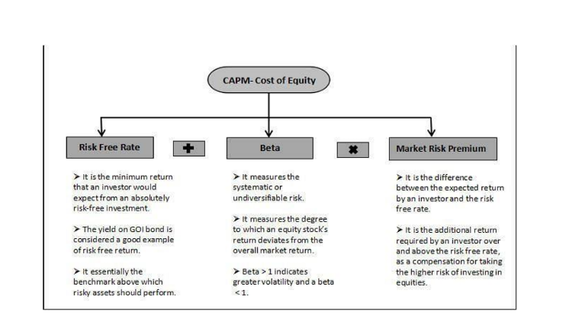

HARDWARE AND SOFTWARE REQUIREMENTS:
Hardware Components:
1. Software: The system should be built using a programming language such as Python or R.
2. Database: The system should be able to store and retrieve large datasets of financial data.
3.Statistical Analysis Software: The system should be able to use statistical analysis software such as Excel or Python for data analysis.
4.Data Visualization Tools: The system should be able to use data visualization tools such as Tableau or Power BI to present complex data in a clear and concise manner.
5.Operating System: The system should be compatible with a variety of operating systems, including Windows, macOS, and Linux.
6.Hardware: The system should be able to run on a high-performance computing infrastructure with multiple CPU cores and ample memory.
Software Components:
1. Data Collection: The system should be able to collect historical financial data from [Company Name] including stock prices, earnings per share, dividend yield, and macroeconomic variables such as interest rates, inflation, and GDP growth.
2. Data Analysis: The system should be able to analyze the collected data using statistical analysis software to estimate the beta coefficient of [Company Name] and calculate the expected return on its stock using the CAPM model.
3. CAPM Model Implementation: The system should be able to implement the CAPM model and calculate the expected return on [Company Name]'s stock based on its level of risk.
4. Financial Statement Analysis: The system should be able to analyze the financial statements of [Company Name] to extract relevant information, such as earnings per share, dividend yield, and other firm-specific factors that can influence the stock price.

IV. MPLEMENTATION

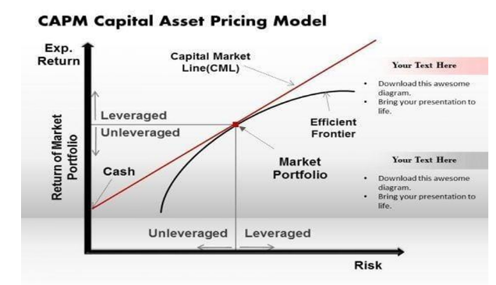

The CAPM (Capital Asset Pricing Model) model is a financial tool that estimates the expected eturn on a stock based on its systematic risk, as measured by its beta coefficient. The model consists of five components: data collection, CAPM model, financial statement analysis, macro- economic data analysis, and report generation. The user interface allows users to input company data and select analysis options, while the data warehouse stores historical financial data and macro-economic data. The CAPM model calculates the beta coefficient and expected return on stock, while financial statement analysis and macro-economic data analysis provide additional insights. The system should be able to collect historical financial data from [Company Name] including stock prices, earnings per share, dividend yield, and macroeconomic variables such as interest rates, inflation, and GDP growth. The report generation component produces a comprehensive report with estimated beta coefficient and expected return on stock, as well as key findings and recommendations.
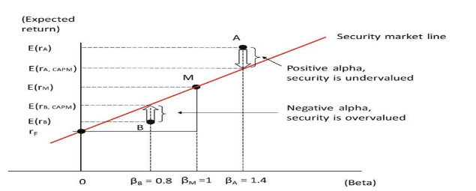
User Interface (UI) Frontend: Web interface for users to input company data and select analysis options
Backend: API layer for data processing and communication with other components
Data Warehouse Historical Financial Data: Store historical financial data for companies.
Macro-Economic Data: Store macro-economic data for analysis.
CAPM Model Beta Calculation: Calculate beta coefficient using historical financial data.
Expected Return Calculation: Calculate expected return on stock using beta coefficient and risk- free rate.
Financial Statement Analysis Financial Statement Processing: Process financial statements to extract relevant information.
Financial Statement Analysis: Analyze financial statements to identify trends and patterns.
Macro-Economic Data Analysis Macro-Economic Data Processing: Process macro-economic data for analysis.
Macro-Economic Analysis: Analyze macro-economic data to identify trends and patterns.
V. RESULTS & DISCUSSION
Results:

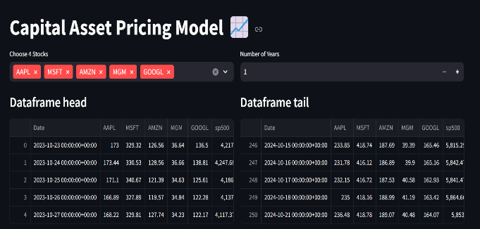

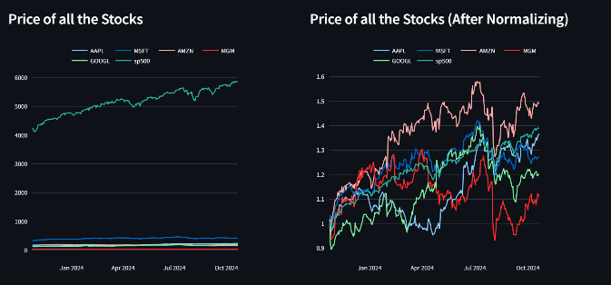

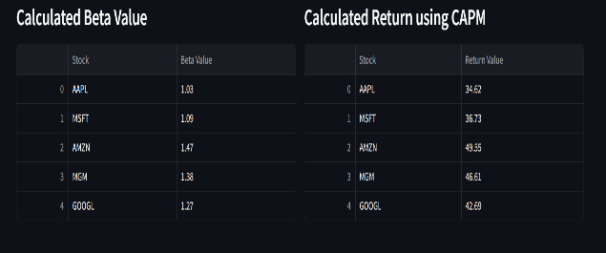
VI. CONCLUSION
This research highlights the transformative potential of integrating machine learning techniques and real-time data analysis into financial evaluation processes. By addressing the limitations of traditional models like CAPM, the proposed system aims to enhance predictive accuracy and risk assessment, ultimately empowering investors to make more informed decisions.The implementation of advanced algorithms and real-time data integration is expected to yield significant improvements in forecasting asset returns and understanding risk exposure. Moreover, the user-friendly dashboard will facilitate accessibility, making sophisticated financial analysis available to a broader audienceAs financial markets become increasingly complex and dynamic, the need for adaptive, data-driven approaches becomes paramount. This study not only contributes valuable insights to the field of financial evaluation but also lays the groundwork for future research into more advanced systems that harness the power of machine learning and big data to optimize investment strategies and risk management.
VII. FUTURE SCOPE
Future research will explore advanced machine learning algorithms and alternative data sources, such as sentiment analysis and macroeconomic indicators, to enhance predictive accuracy. Additionally, developing real-time portfolio optimization features and addressing ethical considerations will ensure transparency and compliance in financial evaluation methodologies, adapting to the evolving market landscape.
VIII. REFERENCE
Harry Markowitz, 1952. “Portfolio Selection,” Journal of Finance, American Finance
Association, vol. 7(1), pages 77–91, March.
Research on the Application of CAPM Model in Investment 145
2. Sharpe, William F. “Capital asset prices: A theory of market equilibrium under conditions of
risk.” The journal of finance 19.3 (1964): 425–442.
3. Lintner, John. “Security prices, risk, and maximal gains from diversification.” The journal of
finance 20.4 (1965): 587–615.
4. Mossin, Jan. “Equilibrium in a capital asset market.” Econometrica: Journal of the econometric society (1966): 768–783.
5. Cremers, Martijn. “Reviving Beta? Bayesian Test of Efficiency and the CAPM.” Available at
SSRN 276177 (2001).
6. Levy, Haim. The capital asset pricing model in the 21st century: analytical, empirical, and
behavioral perspectives. Cambridge University Press, 2011.
7. Annual report of Amzon.com, Inc., 2021, UNITED STATES SECURITIES AND
EXCHANGE COMMISSION, https://www.sec.gov/ix?doc=/Archives/edgar/data/000101
8724/000101872422000005/amzn-20211231.htm
8. Annual report of Amzon.com, Inc., 2020, UNITED STATES SECURITIES AND
EXCHANGE, https://www.sec.gov/ix?doc=/Archives/edgar/data/0001018724/000101
872421000004/amzn-20201231.htm

